**Practical No 4**

Aim: Study and Implementation of storage as a Service:

Theory:

* Storage as a service (SaaS) is a business model in which a company leases or rents its storage infrastructure to another company or individuals to store data. Small companies and individuals often find this to be a convenient methodology for managing backups, and providing cost savings in personnel, hardware and physical space.
* A company providing SaaS may be called a storage service provider (SSP). Storage as a service can also be referred to as hosted storage
* Storage as a Service is a business model in which a large company rents space in their storage infrastructure to a smaller company or individual.
* In the enterprise, SaaS vendors are targeting secondary storage applications by promoting SaaS as a convenient way to manage backups. The key advantage to SaaS in the enterprise is in cost savings --in personnel, in hardware and in physical storage space.
* For instance, instead of maintaining a large tape library and arranging to vault (store) tapes offsite, a network administrator that used SaaS for backups could specify what data on the network should be backed up and how often it should be backed up.

Procedure: -

Step 1: Login to Gmail Account and go to Google Drive

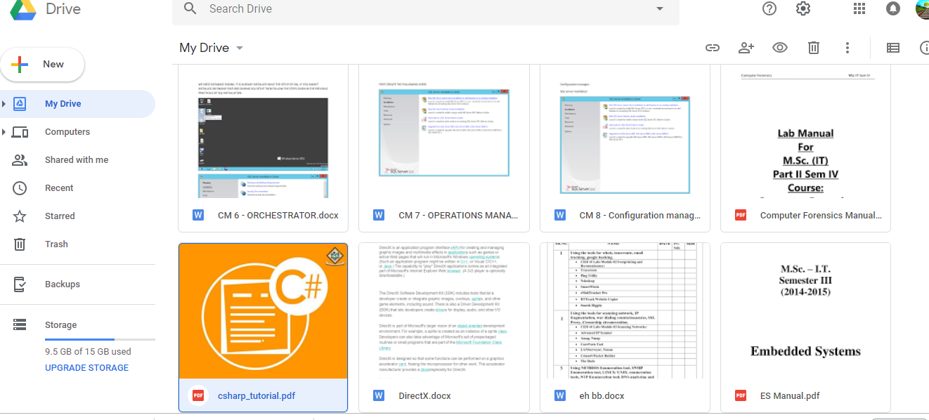

Step 2: Right click on My Drive

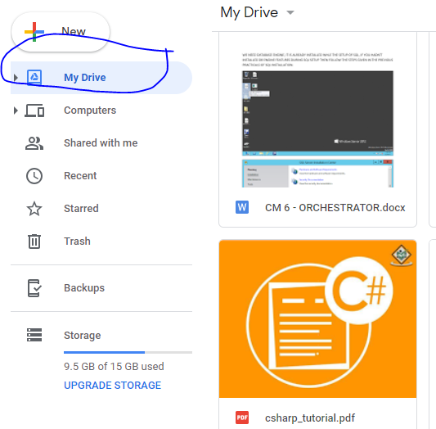

Step 3: Right click on my Drive

Select -> More-> Google form

From here we can create google forms

Now Type the question or any thing which you want

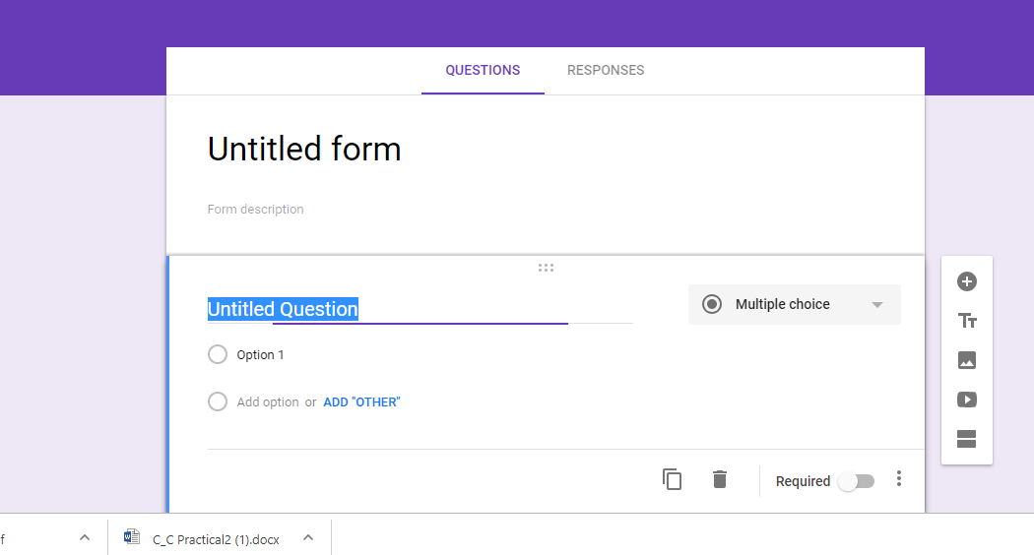

Step 4: select my drive Right click on that and create google document and save the document.

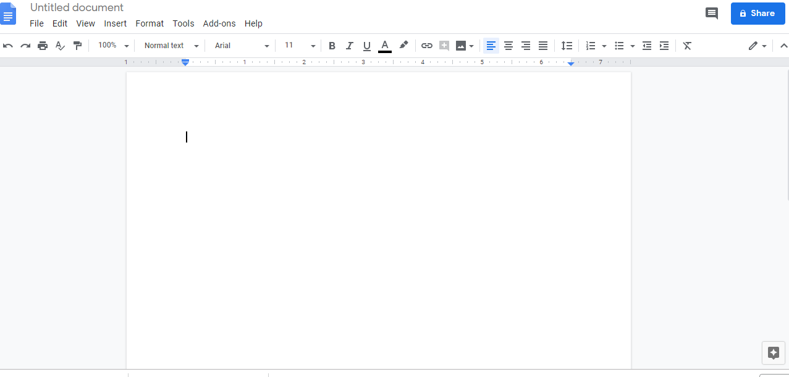

Step 5: select my drive click on create slide

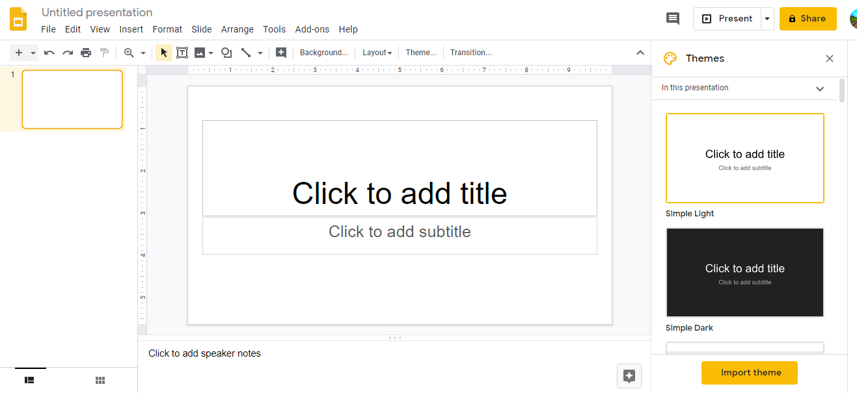

Step 6 : you can upload file or folder by using upload file and upload folder tab.